**Problem Statement:**

**Create a generic stack class using C++ templates, which supports basic stack operations like push, pop, peek, and isEmpty. This stack should be capable of handling any data type (e.g., int, float, char, etc.).**

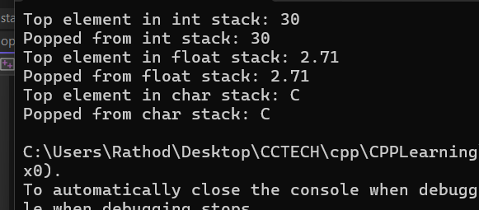

Learning

Templates allow you to write generic and reusable code in C++. They enable the creation of functions or classes that can work with any data type without rewriting the code for each specific type. Templates are essential for writing libraries like the Standard Template Library (STL).